Applying Level Curves

Objective: to use what we know about level curves and apply it to contour maps and surfaces

1. Intro to topo maps: <http://www.nps.gov/webrangers/activities/readingmap/> Go through the reading a map interactive.

2. You will be going to a website where you will compare a contour map with an actual panoramic picture of the location. Your goal is to find the location on the contour map where the picture was taken. Use your knowledge of level curves, and what you see in the panoramic to discuss possible locations with your group. Click where you think the location is on the contour map and see if you are correct. If you are, go on to the next problem, if not try again. Make sure you answer the questions below.

To get to the first problem:

Open TopoPano Explorer SITEDemo

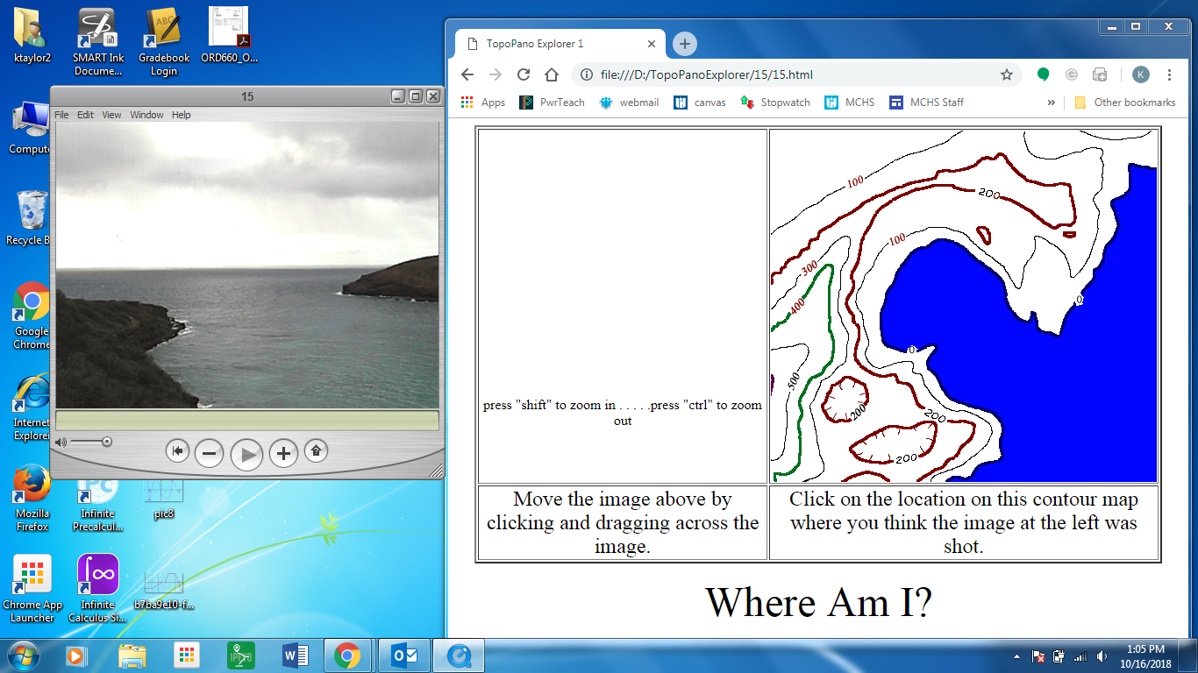 The videos are very old, so some updated windows media players will not allow the video to open in the website. Open QuickTime from the Start Menu, then from QuickTime, open the corresponding video. Each video number can be seen from the URL in the Demo, or look below in the ( ) for video number.

Resize the windows so you can see both at the same time and are able to click back and forth without hiding anything similar to this:

Follow the directions on the website as to how to navigate the video.

Group members:

How many times did it take you go get it right?

Picture 1 (15): Picture 2 (04): Picture 3 (17):

Picture 4 (20): Picture 5 (01): Picture 6 (03):

Which panorama was the most difficult to find the location? Why?